

Registration Form for Eggstra Special Easter Hunt

@ Highland Presbyterian Church on March 24, 2018

Child’s Name___________________________________ Age:_________

Parent’s Names_________________________________________________________

Email address__________________________________________________________

Phone numbers (in case we need to contact you with questions) _________________________________________________________________________________

What special accommodations does your child need for the egg hunt? Please consider group size, physical limitations, diet, etc. Provide any information that will help us plan the best hunt for your child._____________________________________________________________________ __________________________________________________________________________________________________________________________________________________________________________________________________________________________________________________________________________________________________________________________________________________________________________________________________________________________________________________

Would your child like to be assigned an “Easter Buddy” (a 4th-12th grader that will accompany your child throughout the hunt)?

Yes No

What prize could your child win in their Easter Egg that would put a huge smile on their face? _____________________________________________ _____________________________________________________________________________________

What is your child’s favorite color? ______________________________________

Would you prefer prizes or candy/treats for your child’s egg? Be specific____________________________________________________________________________________________________________________________________________________________________

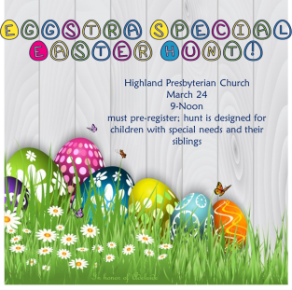

Registration Form Page 2

Child’s Name___________________________________ Age:_________

Activities and snacks will be set up in our Fellowship Hall along with WJTL Kid’s Cookie Break. What activity does your child like to do? Coloring? Reading? Play-doh/sensory? Be as specific as you’d like. What snacks would/can your child eat? ____________________________________________________________________________________________________________________________________________________________________________________________________________________________________________________________________________________________________________________________________________________________

If your child needs a “calming space” what would they like in that space? ____________________________________________________________________________

If your special needs child has a sibling, please list their names and ages and if they are going to participate in the Easter Egg Hunt at the end just for them and the Easter Buddies.

Name_____________________________________________________Age________ yes/no

Name_____________________________________________________Age________ yes/no

Name_____________________________________________________Age________ yes/no

*Is there anything special we need to know about these siblings? Our hunt is always nut free, and kids can always trade in candy for prizes at the end if they can’t eat it.*

_____________________________________________________________________________________________________________________________________________________________________________________________________________________________________________________________________

This hunt is going to be tailor-made to the kids that register so please be as specific as possible when telling us about your child ☺ We want this to be a fun event for them, their siblings and you! Once your child is registered, we will send you an email detailing the event and time and any questions we may have. In the meantime, feel free to email Laurie Juarez with any questions! lauriejuarez@highlandpc.org

